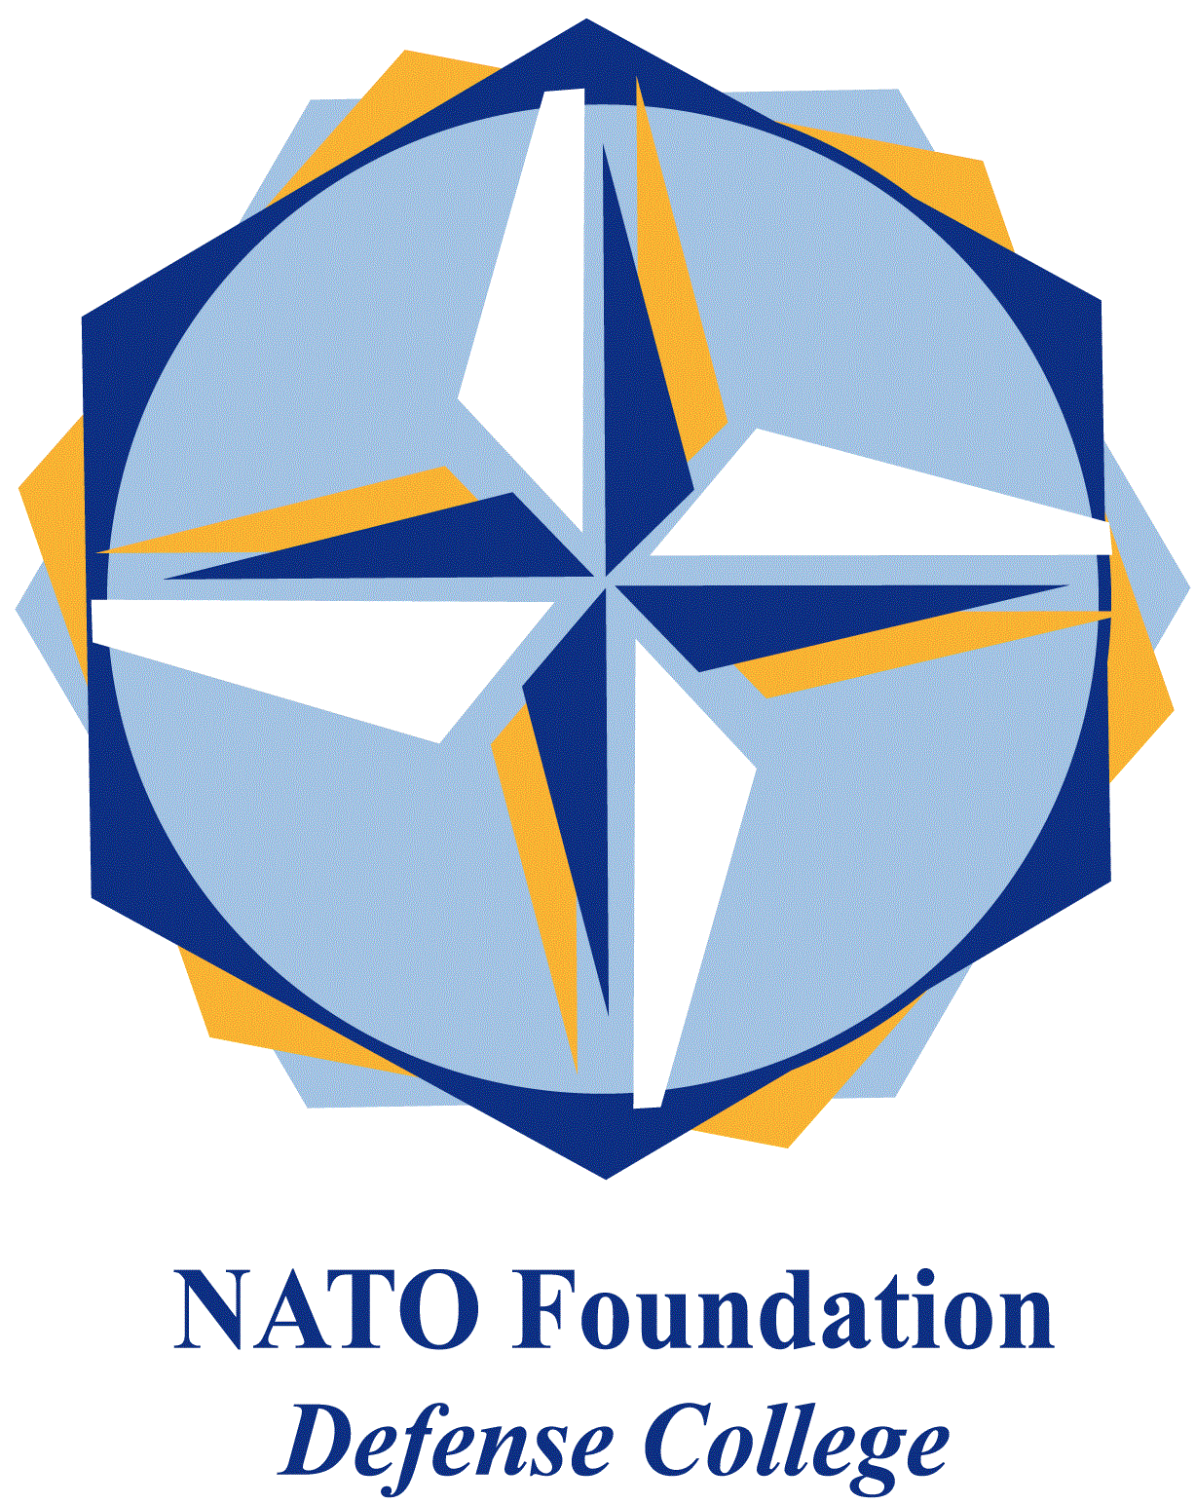
NATO DEFENSE COLLEGE FOUNDATION
STRATEGIC TRENDS
December 2015
BALKANS
Kosovo: a European terrorist hub?
The current crises in Middle East are attracting a large number of foreign fighters from the Balkans, and this is leading to growing public attention on the matter. The consequences of a large number of European citizens fighting in Syria and Iraq are potentially dangerous for the overall European security. The phenomenon of foreign fighters, despite being already widespread all over Europe, in the Balkans is assuming a particularly alarming profile, for both the number of individuals involved and the extent of the territories impacted.
As a matter of fact, the indoctrination and the recruitment of foreign fighters is facilitated by the large presence of Muslim believers (generally tolerant) together with the political and economic weakness of the region. In the Balkans, at the moment, there are two major areas of instability and terrorist penetration: Kosovo and Bosnia-Herzegovina, while some 20 terrorist cells might be active in there.

In Kosovo, the former Serbian province that self-declared its independence since 2008, the ethnical Albanian majority obtained its independence from Belgrade thanks to the NATO bombing campaign in 1999. Historically Kosovo is an underdeveloped country, where the illicit trafficking and smuggling of persons, weapons and drugs represents the main business. Despite independence, NATO control and the European Union administration, the situation in Kosovo still remains critical.

The lack of accountable politics and catastrophic economics facilitated the penetration of radical Islamism, which probably found also connections with local terrorist groups. These fighting groups in fact use the religious factor as a weapon to foster the nationalists cause in the region. Although officially Pristina affirmed that only 40 people were recruited, at the moment probably about 300/400 Albanians, mostly Kosovars fight with Dawla (DAESH). In Kosovo the recruitment of foreign fighters is probably active from at least two years, as shown by a note signed by Secretary of State John F. Kerry in September 2014, declaring that Lavdrim Muhaxheri (a terrorist known for his gruesome videos) “committed, or poses a significant risk of committing, acts of terrorism that threaten the security of U.S. nationals or the national security, foreign policy, or economy of the United States”.

Lavdrim Muhaxheri, also known as Ebu Abdullah el Albani or Abu Abdallah al-Kosovo, is recognized as the leader of a “Balkan brigade” active in Syria. The history of Lavdrim Muhaxheri is quite confused, someone also tells that he worked for years in the main US military base in Kosovo (Camp Bondsteel), but is clear that his popularity is due to his utilization of the social networks. In particular, he released two videos in which he decapitates and kills Syrian prisoners and invokes the holy war, ripping his Kosovar passport declaring that Islam is his only homeland.
Beyond the icon of Muhaxheri, what clearly appears is that the recruiting of foreign fighters and the extremist Islamic proselytism found in Kosovo a fertile ground. The presence of former nationalist terrorists groups and of several Islamic oriented NGO and relief associations make the situation even more tangled. Furthermore, the government of Pristina seems unable and unfit to keep the situation of the country under control. For example, Kosovo didn’t even approve a law directed against the recruiting or the enlisting of foreign fighters, as well as a proper law punishing foreign fighters themselves.
On the other hand the government banned some 16 foreign-financed NGOs suspected to spread jihadism and carried out anti-terrorist operations arresting dozens of suspects and putting them to trial.

